Dr.S.PRIYANKA, RESUME
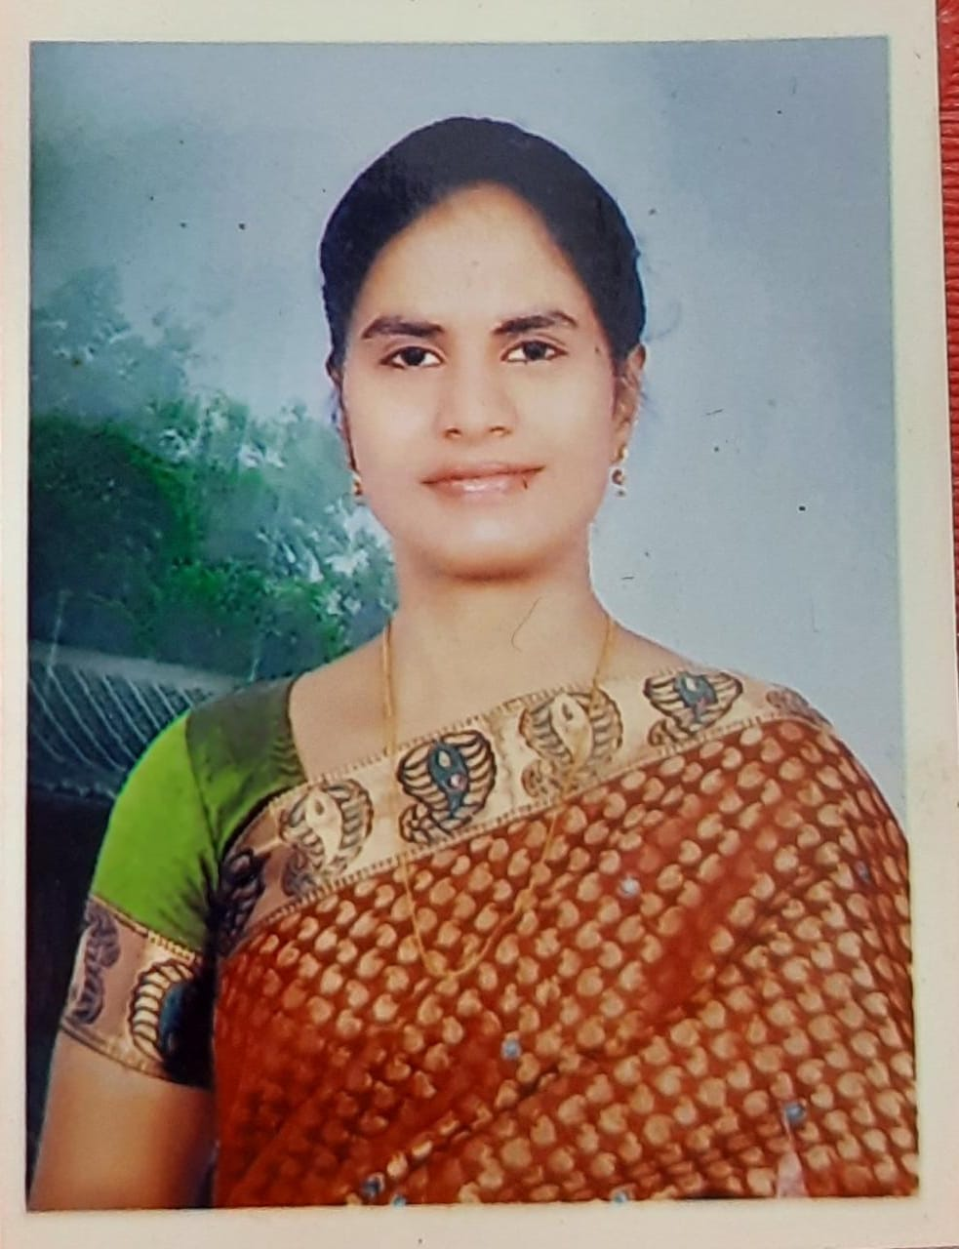
PROFESSIONAL RECOGNITION

- Dr. S. Priyanka M.Sc., Ph.D. Assistant Professor in Biotechnology is having 9 +years of Teaching Experience at UG level.
- Awarded the degree of Doctor of philosophy on the topic ”PROTECTIVE ROLE OF MELATONIN AGAINST ALUMINIUM ACETATE ON ALBINO MICE” on 02/02/2013
- Qualified in CSIR National eligibility test conducted by CSIR-UGC in 2007.
- Qualified in GATE IN 2008.
- Worked in as NSS Programme officer and member for 9 years (2013-2015& 2019 To till now) and Conducted NSS special camps

ACADEMIC ACTIVITIES
Admission committee, Admission incharge for the department of biotechnology
Acted as convener and committee member for the college level committee,
NSS committee, NAAC committee member

SEMINARS ORGANIZED
Organising secretary and Convenor for One day NATIONAL LEVEL SEMINAR on “CURRENT TRENDS IN BIOLOGY AND BIOINFORMATICS APPLICATIONS” on October 24, 2016.

WORKSHOPS ORGANISED
- Co-convenor for One day workshop on PLANT TISSUE CULTURE TECHNIQUES on February 5, 2019.
- Convenor for 2 Day Workshop on “Plant tissue culture and Phytochemical analysis” 2nd and 3rd March 2020 Organized by Department Of Biotechnology & Botany In collaboration with VFSTR (Deemed to be University), Vadlamudi, Guntur.

CO-CURRICULAR ACTIVITIES
- Practical external examiner at NTR Govt. degree college (W), Mahabubnagar from 22-02-2014 to 26-02-2014.
- Examination Panel member and Paper setter for the semester –end examination for UG CBSE, B.Sc Biotechnology to examination branch, Telangana university, Nizamabad-503322.
- Examination Panel member Paper setter for the semester –end examination for UG CBSE, B.Sc Biotechnology to examination branch, Girraj Govt College(A), Nizamabad-503322.
- Nominated as chairman of Board of studies in Biotechnology o f Govt College for women (A), Guntur for the academic year 2018-2019.
- Nominated as member of Board of studies in Biotechnology of MVS Govt College(A), Mahabubnagar for the academic year 2017-2018.
- Nominated as member of Board of studies in Biotechnology of TARA Govt College(A), Sangareddy, Medak (Dist) for the academic year 2018-2019.
- Nominated as member of Board of studies in Biotechnology of MVS Govt College(A), Mahabubnagar for the academic year 2018-2019.
SOCIAL ACTIVITIES
Acted as NSS Programme officer special camps are conducted by the college in adopted villages and more concentration was focused on social evils, importance of literacy rates, AIDS awareness, clean and green., Blood donation camps were organized in the college level.

COURSES UNDERTAKEN
- Orientation course:
Orientation Program held from 9th may to 5th June, 2013 at UGC-Academic Staff College, Maulana Azad Urdu University Gachibowli, Hyderabad-500 032, A.P. and obtained A Grade.
- Refresher Course:
Refresher Course held from 16th August to 5th September, 2017 at UGC-Human Resource Development College, University of Hyderabad , Gachibowli, Hyderabad-500 032, A.P. and obtained A Grade.
- Refresher Course:
Refresher Course held from 16th November to 28th November, 2020 at UGC-Human Resource Development College, University of Hyderabad , Gachibowli, Hyderabad-500 032, A.P. and obtained A+ Grade.

LECTURES DELIVERED
    - Extension Lecture on 30-09-2013 at Girraj Govt College(A), Nizamabad on the topic “GENOME ORGANISATION IN EUKARYOTES”
    - Extension Lecture on 31-10-2014 at NTR Govt College(A), Mahabubnagar on the topic “GENE THERAPHY”
    - Extension Lecture on 15-07-2022 at BGR Degree College(A), Nellore on the topic “BIOREMEDIATION”
- BOOK CHAPTER/BOOK PUBLISHED:2

PRESENTED PAPERS IN ABSTRACTS/SUBMMITTED IN SYMPOSIUM/SEMINARS AND CONFERENCES
NATIONAL SYMPOSIUM/SEMINARS AND CONFERENCES
1. S.Priyanka, B.Devaprasad Raju, K.Jayantha Rao, N.John Sushma(2008) “Impact of aluminum acetate on histology of albino mice” (18-20,Dec-2008) SBCI 77th Annual meeting on Impact of Basic and Translational Research on Medicine, Agriculture and Industry.(Poster Presentation), IIT-Madras.

2. Raja Kumari.S, Priyanka.S, Auradha.P, Jayantha Rao.K, N.John Sushma(2009).Sub cloning and expression of nucleocapsid protein in E.coli(11th -12th Sep-2009) National seminar on recent trends in life sciences for human welfare (Oral Presentation) Guntur.

3. Rajini.V, Pratibha Sree.T, Priyanka.S, Tanuja.J, K.Jayantha Rao, N.John Sushma(2009)“Effect of aluminum on albino mice”(14th-16th Nov-2009)2nd AP Science Congress (Oral Presentation) Tirupati.

4. S.Priyanka and N.John Sushma(2010),Transgenic animals-Bio Ethical issues(25th -26th Feb,2010 National seminar on Trends in Bioethics, Biosafety & Intellectual property Rights (Oral Presentation) Tirupati.

5. P.Lakshmi Sravanthi, B.Mahitha, S.Priyanka and N.John Sushma(2010) Histopathological responses in liver and kidney of albino mice after exposure to aluminum (27th -28th March 2010)National conference on Frontiers in Biotechnology (Poster Presentation) Tirupati.

6. S. Priyanka, B. Mahitha, K. Jayantha Rao and N. John Sushma (2011)
Melatonin alleviate aluminum induced oxidative stress in medulla oblongata of albino Mice. International Conference on BioTechnology in Pharma & Food Industries(ICBPF-2011) (29-30th July 2011) (Poster Presentation) Visakhapatnam

7. Rajakumari and, S. Priyanka
presented paper on ECO-FRIENDLY BIOLOGICAL METHODS IN REDUCTION OF USE OF PESTICIDES National Seminar on ‘Sustainability and Management of Aquatic Ecosystems in Semiarid Areas’ on 7th & 8th January 2015 by Department of Zoology, Government Degree College (Men), Anantapuram.
8. S. Priyanka
Presented paper on” Status of women in present society”. National level seminar on Rural women empowerment-sustainable development-6&7 January, 2015 organised by Department of economics,NTR.Govt Degree college, Mahabubnagar.

8. Rajakumari , S. Priyanka and V.Srinivasulu
Presented paper on” Role of Camellia Sinensis on Reduction of Obesity”. UGC-Sponsored national symposium Genomics a gate way to future-18th March, 2015, organised by Department of Genetics and Genomics, Yogi Vemana University, Kadapa.
9. S. Priyanka
Presented paper on” institutional safety measures in post lockdown period”. National level webinar on post lockdown academic challenges in higher educational institutions- 28 May , 2020 organised by IQAC, Govt Degree college for women, Guntur.

INTERNATIONAL CONFERENCE PRESENTED
1. N. John Sushma, S. Priyanka, B. Mahitha, and K. Jayantha Rao (Oral Presentation)
Neuroprotective role of melatonin against aluminum-induced oxidative stress in cerebral cortex and medulla oblongata of mouse brain
International conference and exhibition on pharmaceutical biotechnology (6-8,2011) Hyderabad.
2. S. Priyanka
Presented paper on” PASSION FOR SUSTAINABLE ENVIRONMENT”. International virtual conference on spring of life: the perfume of nature-17 to 19 September, 2020 organised by Department of Zoology,.Govt Degree college, Ravulapalem.

INTERNATIONAL SEMINAR ATTENDED
- Bioasia 2010-The Global Biobusiness Forum (3-6th Feb 2010), Hyderabad

- One day National seminar on AEROBIOLOGY AND PUBLIC HEALTH-2014 on 12-12-2014 conducted by Department of Botany, University College of science, Saifabad, osmania university, HYD-500 004.

WORK SHOPS ATTENDED

1. National work shop on present scenario of wildlife management in India (20th -21th August-2009),Tirupati.
2. National workshop on Recent Trends in Bioinformatics (25th - 26th June 2010) Tirupati.
3. National workshop on Advances in modern biology (3rd -5th August, 2010) Tirupati.
4. National Academies of Sciences e-Lecture Workshop on Genomics and proteomics (17th -18th August, 2010) Tirupati.
5.National workshop on Biostatistics-Theory and Practice (17th -19th February, 2011) Tirupati.
6.Attended the one day District Resource centre level workshop on Recent trends in science and technology, 3rd September,2014 organized by District Resource centre , MVS Degree & PG College, Mahabubnagar.
7. Attended the one day state level workshop on Recent trends in horticulture& pest management-3rd December, 2014 organized by University college of science, Saifabad, Hyderabad
8. Attended the three day National level workshop on E-Content, MOOCS and MOODLE, 6-8TH February,2019 organized by Govt. College for Women(A), Guntur.

TRAININGS and FACULTY DEVELOPMENT PROGRAMME
NISME, Department of Science &Technology, Govt. of India (29-3-10 to 09-04-10) | Faculty development programme on entrepreneurship development
GCW(A), Guntur and TIFR, Mumbai, 2-3 February,2019 | Hands on Training for Faculty & Students on simple model systems
Organised by CCE,AP,VIJAYAWADA( 07-09-2020 to 11-09-2020) | 5 day Faculty development programme in biosciences
Organised by CCE,AP,VIJAYAWADA( 03-08-2020 to 07-08-2020) | 5 day Faculty development programme in LMS video and pedagogy

RESEARCH PAPERS PUBLISHED
1. Biochemical and histological changes in stomach of Rana tigrina under fenvalerate toxicity, 2009.
Subba Reddy SV, Ravi Sekhar P, DevaRaju T, Jaya Sankar, Priyanka S, Sushma NJ and K Jayantha Rao
Indian journal of comparative animal physiology, Vol, 27(2) p 60-64.

2. Impact of monocotrophos on selected enzymes and histopathological studies of liver with transmission electron microscopy
Mahavee latha P, Ravi Sekhar P, Priyanka S, Devaraju T, John Sushma N and K.Jayantha Rao,2010.
Indian journal of comparative animal physiology. Vol.28 (1), p.16-23.

3. Melatonin prevents aluminum-induced oxidative damage and cytotoxicity in the medulla oblongata of mouse brain, 2011.
S. Priyanka, B. Mahitha, K. Jayantha Rao and N. John Sushma
Journal of Pharmacy Research. 4(3),683-686. Ugc care journal

4. Histopathological responses in liver, kidney, intestine and testis of albino mice after exposure to aluminum, 2011.
N. John Sushma, B. Mahitha, P. L.Sravanthi, S. Priyanka, and K. Jayantha Rao.
International Journal of Pharma and Bio Sciences. Vol 2(1),138-146. UGC CARE JOUNAL

5. Biosynthesis, characterization and antimicrobial studies of AgNPs extract from bacopa monniera whole plant, 2011.
B. Mahitha, B. Deva, Prasad Raju, G. R. Dillip, C. Madhukar Reddy, L. Manoj, S.Priyanka, K.Jayantha Rao and N. John Sushma
Digest Journal of Nanomaterials and Biostructures. Vol 6(1),135-142. UGC CARE JOUNAL

6. Neuroprotective role of Melatonin against aluminum-induced oxidative stress in the hippocampus of mouse brain, 2011

N. John Sushma, S. Priyanka, K. Jayantha Rao

Journal of Applied Pharmaceutical Science. 1(10):126-133. UGC- CARE JOURNAL

7. Melatonin alleviates aluminum-induced oxidative stress in the medulla oblongata of albino mice, 2012.
S. Priyanka, N. John Sushma and K. Jayantha Rao
Journal of Pharmacy Research. 4(3),683-686.
International journal of chemical and Analytical Science, 3(4):1361-1363.-UGC CARE JOURNAL

8. Therapeutic effect of Melatonin against aluminum-induced neurotoxicity in cerebellum of albino mice, 2012.
S. Priyanka, B N. John Sushma and K. Jayantha Rao
Toxicological and Environmental Chemistry. 94(5),1-11. UGC CARE JOURNAL
AWARDS RECEIVED:
Best Administrator Award 2022 by IOT academy, Coimbatore, Chennai, Tamil Nadu, India.

LIVE PRESENTATIONS IN TV TELECAST:
- https://youtu.be/-dD2tjvvh6c
- https://youtu.be/pNzn7-bFwU
BRIEF INTRODUCTION
my self Dr.S.Priyanka qualified M.Sc,CSIR-NET, Ph.D. and working as degree college lecturer in biotechnology since 2013. I have 9+ years of teaching experience. I worked in various committees at college level. I have worked as NSS Programme offlicer and participated in different NSS special camps and social activities since 2013. I worked as Chairman Board of studies (BOS) committee to frame the syllabus. I wrote 2 book chapters in collaboration with publishers. I have research publications. I worked as examiner for examinations to various college and question paper setter for various universities and colleges. I have delivered several extension lecturers to various other college students both at UG and PG level. I have acted as subject expert for srujankura exhibition, vignan university, Guntur. I was a life member for society of biological chemists, Bangalore, India. I am a life member of Indian Red Cross society, New Delhi, India. I have acted as convener and organizing secretary for National seminar and workshops at college level. I have prepared supplied study material to my students and encouraged them for their higher studies and guided them. My students are encouraged for different co-curricular activities participation such as subject specific exhibitions, poster competitions, university level quiz programs, field visits, study projects, industrial training visits and several awareness programmes. I have delivered my study lectures in live TV telecast programmes, which are later uploaded as you tube videos. I have delivered study lectures on podcasts and participated in simplify their educational perspective. I have attended in various seminars, workshops, faculty development programmes and undergone refresher courses for my skill enhancement. I was selected and given Best Administrator Award 2022 by IOT academy, Coimbatore, Chennai, Tamil Nadu, India.

